Quantum Support Vector Machine (QSVM)
(Kernel & Linear-Algebra–Style Quantum ML)

1. Problem
In classical machine learning, Support Vector Machines (SVMs) are powerful classifiers that rely on kernel methods to separate data that is not linearly separable in the original feature space.
However: - Computing kernel values for very high-dimensional feature maps can be expensive. - Some kernels correspond to feature spaces that are exponentially large, making classical computation hard.
Goal of QSVM: > Use a quantum computer to efficiently compute kernel values by embedding data into a quantum Hilbert space, then apply a classical SVM using those quantum-computed kernels.

2. Intuition
The core idea is simple:
- Encode classical data (x) into a quantum state (|(x)).
- Define a quantum kernel as the overlap between two states:
- [ K(x, x’) = |(x) | (x’) |^2 ]
- Use these kernel values in a classical SVM optimizer.

Why quantum helps
- Quantum states naturally live in exponentially large Hilbert spaces.
- Inner products (overlaps) can be estimated using quantum interference.
- Certain feature maps may be infeasible to compute classically but natural on quantum hardware.
Think of QSVM as: > “Let the quantum computer handle feature mapping; let the classical computer handle optimization.”

Circuit Structure
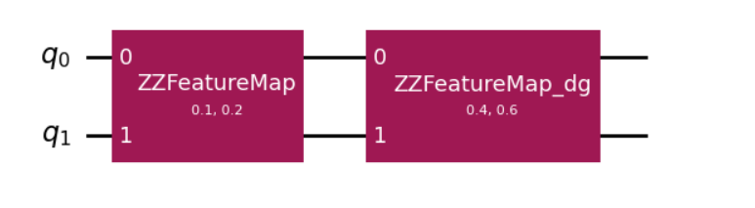
A QSVM circuit has three main components:

(a) Feature Map Circuit
A parameterized quantum circuit (U_(x)) that encodes data (x) into a quantum state:
[ |(x)= U_(x) |0^{n} ]
Typical gates: - Hadamards (create superposition) - Data-dependent rotations (RX, RY, RZ) - Entangling gates (CX, CZ)

(b) Kernel Evaluation Circuit
To compute (K(x, x’)):
- Apply (U_(x))
- Apply (U_(x’)^)
- Measure probability of returning to (|0^{n})
Mathematically:
[ K(x, x’) = || U_(x’)^U_(x) |0 |^2 ]

(c) Classical SVM
- Kernel matrix (K_{ij} = K(x_i, x_j)) is computed
- Standard SVM optimization is solved classically

4. Simple Math View

Classical SVM (Kernel Form)
Decision function:
[ f(x) = _i _i y_i K(x_i, x) + b ]
Where: - (x_i): support vectors - (y_i): labels - (_i): learned weights - (K(x_i, x)): kernel

Quantum Kernel
Instead of an explicit feature map ((x)):
[ K(x, x’) = |(x) | (x’) |^2 ]
No need to ever write ((x)) explicitly — the quantum circuit is the feature map.

5. Code Example (Qiskit)
Below is a minimal QSVM-style kernel example using Qiskit:

!pip install qiskit qiskit-aer qiskit-machine-learning
import numpy as np
from qiskit import QuantumCircuit
from qiskit.quantum_info import Statevector
from qiskit.circuit.library import ZZFeatureMap

feature_map = ZZFeatureMap(feature_dimension=2, reps=2)

def quantum_state(x):
"""Prepare |phi(x)>"""
qc = QuantumCircuit(feature_map.num_qubits)
qc.compose(feature_map.assign_parameters(x), inplace=True)
return Statevector.from_instruction(qc)

def quantum_kernel(x, y):
"""K(x, y) = |<phi(x)|phi(y)>|^2"""
psi_x = quantum_state(x)
psi_y = quantum_state(y)
return abs(np.vdot(psi_x.data, psi_y.data))**2

X_train = [[0.1, 0.2], [0.4, 0.6]]
X_test = [[0.2, 0.3]]

# Kernel matrices
K_train = np.array([[quantum_kernel(x, y) for y in X_train] for x in X_train])
K_test = np.array([[quantum_kernel(x, y) for y in X_train] for x in X_test])

print("Training kernel:")
print(K_train)

print("Test kernel:")
print(K_test)

You would then feed K_train and labels into a classical SVM (e.g., from scikit-learn).

6. Where QSVM Is Useful

Best use cases
- Small to medium datasets
- Problems where nonlinear decision boundaries are important
- Exploratory research into quantum feature spaces
- Situations where classical kernels perform poorly

Example domains
- Chemistry and materials classification
- Finance (pattern recognition)
- Anomaly detection
- Quantum data (naturally quantum states)

7. Limitations

Hardware & Practical
- Kernel evaluation requires many circuit executions
- Noise severely degrades kernel estimates
- Current devices limit qubit count and circuit depth

Theoretical
- No guaranteed quantum advantage for general data
- Some quantum kernels can be efficiently simulated classically
- Risk of overfitting due to highly expressive feature maps

Scaling
- Kernel matrix scales as (O(N^2))
- Large datasets quickly become impractical

8. One-Sentence Summary
QSVM uses a quantum computer to compute kernel inner products in a high-dimensional Hilbert space, while classical optimization performs the final classification.

